Semester Project 1

Bergen scs

Emil Strøm | Front-End Development | 16.12.2018

<http://www.physnix.com/SemesterProject>

Brief

This document includes my report on the semester project as well as documentation and reflection over the tools I used, decisions that I made, technical reports, possible flaws and/ or improvements that I might’ve missed, not had time to do, or wish I had done differently. I’ve used many of my tools to complete this assignment, but I’ve mainly used HTML, CSS, JavaScript, Bootstrap 4.0, Photoshop and the world wide web as a dictionary.

The task

The task at hand was creating an informative webpage appealing to children aged 7-15 and their parents. The nature of the task lead me to deciding that focusing on parents but still having images to show to their kids would be the best approach. For any webpage out there, the main objective is to have sales and/ or interactions, and any child that wishes to do something today, needs approval from their parents first. The same rule applies in school situations where teachers make decisions.

Planning stage

In this section of the document I will reflect, detail and discuss my thoughts and decision making, as well as the process behind the planning stage of the website.

My planning stage for this project was very short compared to what I’d like it to be, I spent less time on planning the website than creating it. However, I spent quite a lot of time researching, looking at inspiration and having internal discussions with myself about how the assignment should be solved. As soon as I read the assignment text, I started with looking at similar websites and taking inspiration and note their strategies to solve their task at hand.

Immediately after researching I had a general idea of what I wanted the site to look like, I had a prompt “vision” of the sites final look, especially the landing page or “home-page”.

I drew up some sketches of the landing-page as I was un-certain on how I wanted to present all the content without making it like other sites out there, I wanted to make sure my site would “stand-out”. However, given the nature of the assignment; “Interactive Science Museum”, in my hometown, I concluded that competition would not be one of my concerns, and creating a somewhat interactive website would be the best approach.

Here are some of the sketches and initial ideas for the landing-page;

SEE NEXT 2 PAGES

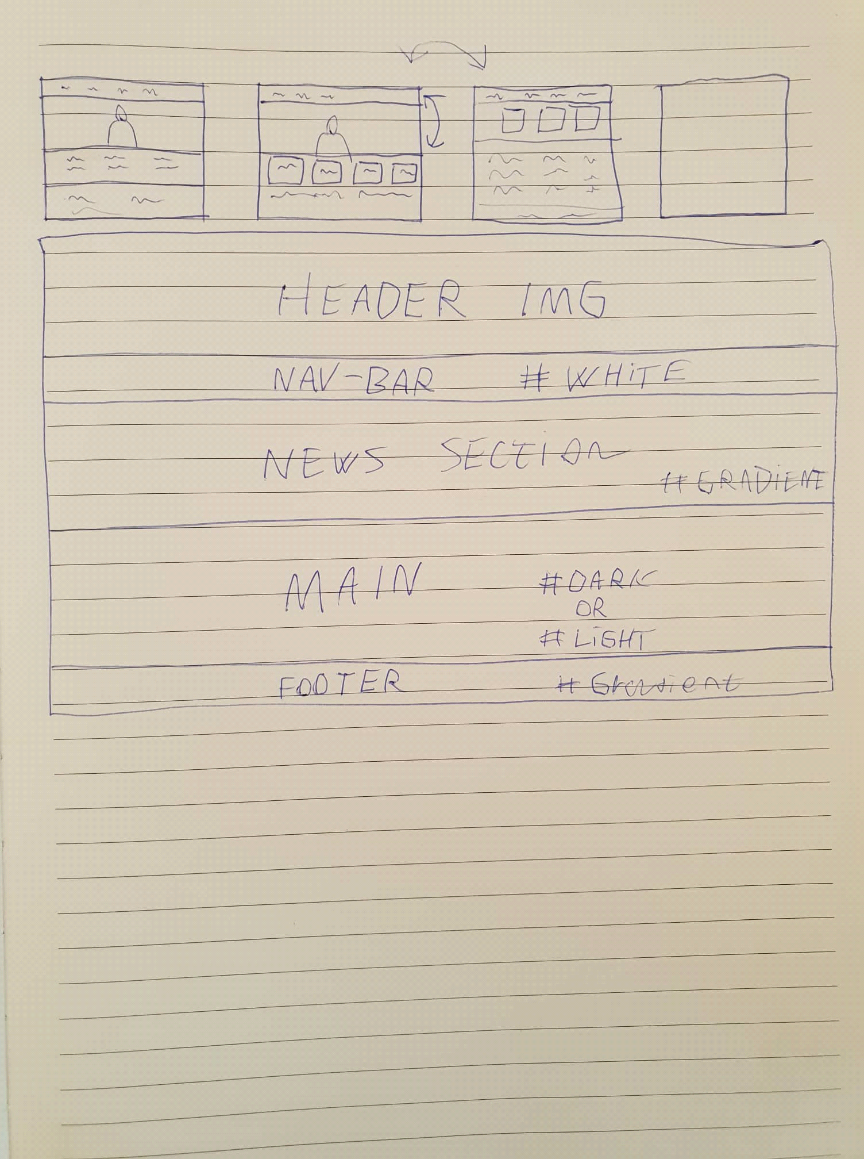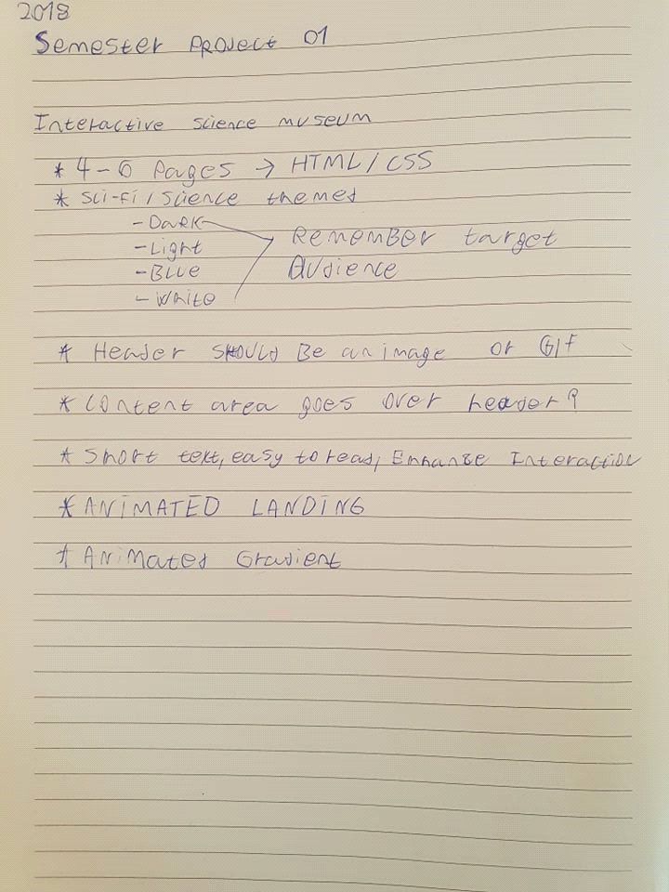

(Sorry for the bad hand-writing)

The initial idea had struck into my head, no idea how or why, but when I read the assignment, I was sure. I had some trouble deciding exactly how I wanted the UI to look like but in the end, I found what I believe, looked and felt the best.

Design stage

In this section of the document I’ll be covering my decision making and process on the use of colors, images and fonts.

I started by considering design, but I was not too sure how I wanted to do this part of the assignment. Did I want to make a styletile or did I want to create a graphic profile, or maybe skip the whole part of this process?

After a lot of thought, I decided that I knew exactly what I wanted, modern, material windows styled colors. I simply did not need to create a Style Tile nor a graphic profile, however, just to reflect on these, I’ll go over the benefits of doing so, and why you should.

When you are creating a website, unless it’s for personal use, you’ll be under a contract, you’ll be creating a website for a customer, who pays for your expertise.

Part of the expertise a Front-End Developer should have is most definitely, the ability to use and understand the importance of a Style Tile or graphic profile. Without it, communicating with your customer will be difficult, and the process might take longer than necessary. Therefor creating a Style Tile or graphic profile, that you can both use for easier access to color and textures and discussions with your customer before you start the creation of the website, overall, I think this process is important to ensure good communication and professionality.

Unfortunately, I decided to proceed without a profile or Style Tile, this is something I tend to do a lot, which limits my designing process and I should focus more on this vital process.

The landing page uses a variety of CSS animations, animated gradients and light/ dark simplistic and materialistic like feel. I decided to proceed with this color scheme as it has shown to succeed in multiple platforms of modern technology, both with children, youths and adults/ seniors. Material design is simply just “soothing” or “relaxing” to watch, it’s pleasing for your eyes and contrasts well with their representative colors.

My color scheme is based on these principals, it should be relaxing to watch yet interesting enough to catch your attention, hence my decision on using an animated gradient for the section headers, news-section and footer. This design repeats itself throughout the entire site, and creates little to no distraction for users, it’s something you don’t really notice at first, subtle but sleek.

For the other colors presented on my page, as the main-background color and navigation bar color, the navigation bar had to stay white, I did try several other variants of colors and material design colors. But it rendered the UI as a distraction.

The main-background color, however, can be changed into a lot of colors, I found that the two best colors where dark grey as presented on my page and a variation of white, it took some time to decide which colors I wanted here, but I decided that a combination of the two variations of grey and dark grey worked best.

Furthermore, I decided to go for some subtle animations like the underlined link animation, three flipping cards, sections floating in from the sides on scroll and the main title of the page “bouncing” on page-load. These animations stay out of the way, are not distracting and gives the landing-page a “fun” feel. Which in turn, suits the target audience.

However, using animations on a web-page is generally something that should be carefully considered, especially considering the amount of distraction they may produce. Which is why I decided to only use them on the landing-page (apart from gradient and underlined-links), the other pages are considered “content-heavy” and should have as little distractions as possible.

In terms of fonts, I must admit. This is something I spent less time on than pleasing. However, I’m happy with the outcome. The most important part of choosing fonts is how they “sound”, when you read the font, and of course; It’s look and feel.

I’m happy with how my fonts turned out on the page, and I think overall it looks pleasing and is easy to read. Which is the most important for the end product, readability, accessibility are two factors that will make a difference in a design’s efficiency.

Image and graphics wise. I decided to stick with the folder provided in the assignment, and only used these images on the site. However, I feel like the page is lacking textures and other icons, I used bootstrap to build the site, and there for a lot of the icons are provided by “font-awesome” (I’ll provide a link to all my resources at the end of the document). I could’ve spent more time creating graphics, textures and possibly finding more icons. But once again I am pleased with the outcome.

Development stage

In this section of the report I’ll be covering my efficiency, tools, strategies and other elements that made the site into what it is.

I always start my development by taking a second look at the sketches and trying to read that sketch in “code” to imagine somewhat what I’ll need to do. I decided that due to the nature of my sketch I wanted to use bootstrap, this to ensure that the site would remain “fluid and responsive” and I’d have to use less time coding it, and of course avoid the “draw-back” of having many media queries, I’ll be covering that later in this section.

Using bootstrap gives me the opportunity to build pages fast in a reliable matter and be ensured it will function properly with little to no draw-backs. However, bootstrap’s framework is built in a way that customization will require you to overwrite a lot of styles, but in general this does not bother me, as bootstrap ensures responsive design which will work on all platforms, and in modern society this is more important than anything else. A website functioning well on all platforms can be the difference between a successful site and an unsuccessful site.

The total time I spent on only coding the site was about 6-8 full work days. And I’m very pleased with the outcome, after pulling the site through validators and WCAG validators it turned out to be a responsive site, within WCAG guidelines with a “AA – AAA rating”. Which means that anyone can use this site, whether they were to be visually impaired, deaf, color-blind or blind on any platform they may wish to do so, whether it be a tablet, phone or desktop.

In terms of media queries and responsiveness, I only used two media queries, one of them too hide the header-image and text on some tablets and phones with a max-width of “900px”.

And the other too resize the fonts of the header image on some sizes with a max-width of “992px”. I’ll be reflecting a bit on media queries to show that I have knowledge about this strategy opposed to bootstrap or other frameworks/ workarounds.

In general, media queries work like this. You can define a minimum-width, maximum-width, device and the devices orientation whether that be portrait or landscape. With these selectors you can define how the site is to be displayed at certain widths, devices and orientations. This can help you ensure that font-sizes, images, elements, UI and other content look exactly like you intend it too which in turn will help you provide a fluid or responsive site design, which once again is crucial in the modern society.

One of the drawbacks with media queries at least in my opinion is the constant changes in technology, especially considering the screen sizes, aspect ratios and new devices being constantly developed. Every year there are new releases which in turn also means that you will have to update your site at least once yearly, however it’s recommended that you do an update quarterly.

Over to more technicalities with my development.

There are quite a few elements that required some extra thought, especially the animations and the “fixed” navigation bar. To solve the first issue with animations I ended up using an external animation style sheet, which were created by a very brilliant developer, I’ll be linking him later in the report. The fixed navigation bar was created by using a bit of JavaScript as well as a “Scroll spy”, of course I’m well-aware that we have not really been taught any JavaScript yet, but I couldn’t resist using the method.

Other more technical elements are the “contact” button, which was also created using JavaScript and a bootstrap Modal, of course, this technically was also not created by me, as this is a part of bootstrap, this resource can be found on bootstrap’s official website under “documentation”. However, creating this myself would not be a problem after looking into the code. But, since I decided to use bootstrap I wanted to use as much of it as possible, not only to keep the code similar, but to learn more about it.

I decided to cut the “contact us” page, and instead use the “Contact/ email button” as well as the information in the footer. I did a “Website Usability Test” or WUT on my parents, the first test was without the button and it took about 150 seconds for my mother to understand how to get to the contact information displayed only in the footer. After going back to the drawing board, and adding a contact button, she spent less than 3 seconds finding the information. So, I’d call it a successful feature. Of course, I could’ve gone for the traditional “Contact us” page with a form and automatic emails. But I decided I wanted to try something new as well as do something different. I could’ve also added the modal to the menu, or a contact form to the modal.

Next, I’ll be talking a bit about my cascading style sheet or CSS, and the use of selectors (ID’s and classes).

I would personally say that the use of classes and ID’s on my site are questionable. I used classes for reoccurring elements, that needed the same styling on the same page.

I used ID’s on reoccurring elements on different pages such as the “UI/ NAV” or on elements that only appeared once per page.

Using selectors like this is not bad, however I feel like the use of these selectors in my CSS was not satisfactory. Especially with the first section of the CSS “Fonts”, this section uses not ID’s nor Classes, but rather I’m selecting every “h1, h2, h5 and p” element on my site, which can be somewhat inefficient, but for this specific site it works.

However, the use of “declarators” is good. I feel like I’m displaying my skillset very well, with the use of more advanced declarators like “overflow, z-index, animation, -webkit-animation, perspective, transitions, transform, backface, grids, object-fit”.

The thing with HTML and CSS and any other development framework really, is that everyone has different ways to get to the same outcome. And I feel like as long as the difference in speed is not too vast, and the outcome is functioning and appealing, the method used to complete the task should not be the main factor. But there are several occasions in my code, where the way I did something is probably a lot more complicated than necessary, or the use of some declarators are wrong.

I have a feeling that my use of “margin and padding” are used in the wrong places, although the outcome turned out to be right.

Lastly, I spent some time optimizing all the images in photoshop. I used the “safe for web” function, and I hope it turned out well. Unfortunately for me, I just moved to a new house without internet, and using my phones internet, so determining the load-time of the site has proven difficult. Which is why I’m adding this section, I know how to optimize images, and I know why it’s important and I feel like it’s important for me to add this to the report just in-case they are not fully optimized.

Reducing the quality, and/ or size of an image and the file-format used will determine if the image is properly optimized or not.

General reflection

In this section I will have a general reflection over my final product, what I could’ve done differently and what I could’ve done better.

Over all I’m very pleased with the outcome of my site, I’ve shown it to several acquaintances as well as a friend that’s very interested in art, and my parents which acted as testing subjects for the site. They’ve all given great feedback and I’m generally happy with the result. In terms of the coding of the site, I would say that this is one of my better assignments and projects in a long time. However, this does not mean it’s perfect.

If I were given the opportunity to re-create the site and start from scratch, there are quite a few things I would do differently. But first and foremost, I would spend a lot more time on the planning stage, making more sketches, creating a Style Tile and spending less time researching. For the duration of the coding section, I feel like this turned out alright, I spent about the time I expected to on the assignment in general.

But I wish I had spent more time in testing stage, as I’m not entirely sure everything works, but on my devices, google inspect devices and validators it turned out to look great on all platforms.

I wish I had spent more time customizing the bootstrap however, I had to ask MJ for some help earlier, and one of the things he mentioned was the obvious “bootstrap look”, which I do agree with in a sense. However, despite the obvious bootstrap, I feel like it turned out very nice, the only part of the bootstrap I’d like to customize more would be the feel of the cards and possibly the navigation bar.

In terms of the general look of the site, I think it looks and feels very nice and smooth to use, easy to read information and it’s all structured in a logical way. Although I decided to only go for 4 pages out of the recommended 4-6, I still think the way I solved the assignment turned out good. If I were to add any pages, it would have to be a “Contact us” and possibly a “Workshop” page, displaying some of the activities you can do in the museum, as a school group or family.

The only other thing I can think of that could’ve been done better in terms of look and feel, would be the text. The amount of text is very hard to balance properly, but I could’ve styled it better, added more pictures or generally just done more with it. I could’ve gotten some GIF’s or Videos for that matter, which I think would make the site over all more interesting. If this was a real project, I would ask the customer to give me more resources to work with.

Sources

In this last section of the document I will be listing all the sources I used.

Whenever I do create a webpage, I end up researching a lot on how to complete what I want, of course I do it in my own way, but reading other solutions helps me get a better understanding of how everything works. And sometimes I honestly just forget how to do something and end up having to search it up quickly. But I know exactly what I’m looking for.

Anyway, here are all my sources for the project:

Dictionaries/ look-up:

[www.fonts.google.com](http://www.fonts.google.com/)

[www.css-tricks.com](http://www.css-tricks.com/)

[www.w3schools.com](http://www.w3schools.com/)

<https://getbootstrap.com/docs>

<https://www.materialui.co/>

[www.stackoverflow.com](http://www.stackoverflow.com/)

Animate.css:

<https://github.com/daneden/animate.css/blob/master/README.md>

Included resources for the assignment in the zip “SemesterProject1”.